STEP-1:SET THE TODO,INPROGRESS,DONE
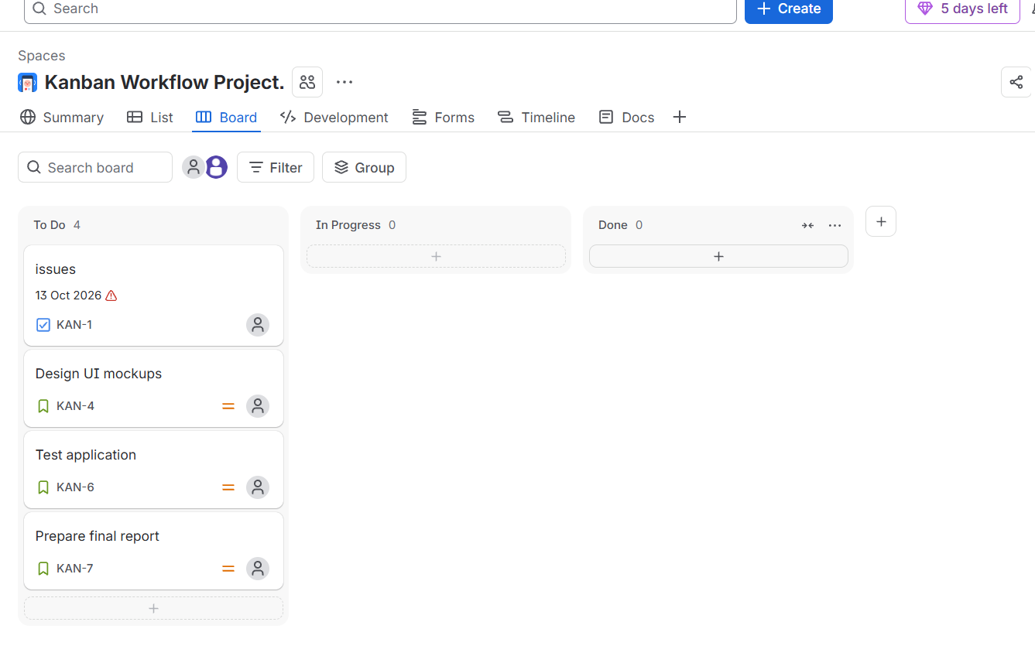
STEP2:ADD TODO,INPROGRESS,DONE


